**The Most Refreshing Premium Deodorant for Men to beat the heat this summer!**

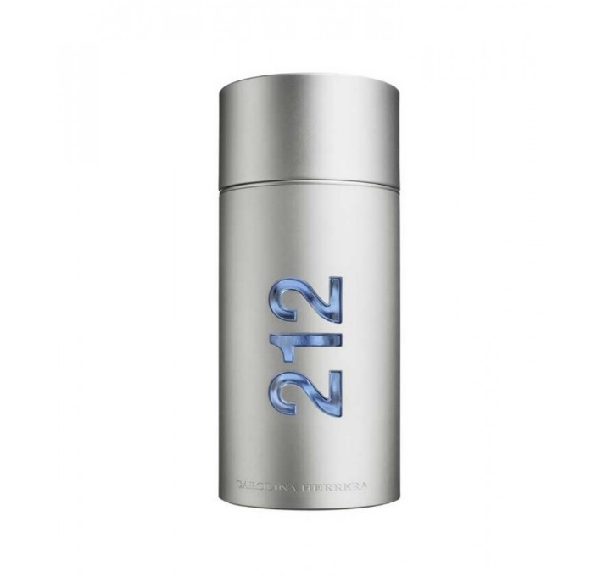

[This Photo](https://www.donbaron.bg/carolina-herrera-212-edt-100ml-m-zhki-parfjum-bez-opakovka) by Unknown Author is licensed under [CC BY-SA-NC](https://creativecommons.org/licenses/by-nc-sa/3.0/)

**Men 212 NYC Deodorant** is one of the (if not THE) most sought-after premium deodorant from the luxury house of Carolina Herrera. Designed to provide a long-lasting protection against odor and sweat, this incredible deodorant leaves a fresh and energetic woody scent that keeps you confident and ready for any occasion.

The 212 NYC Deodorant is an eclectic mix of multiple interesting notes. The top notes are dominated by flower stems, mandarin orange, and bergamot to give that cool citrusy vibe to start with. The middle notes are occupied by gardenia and jasmine to throw some spice in the mix. The base notes are sandalwood and musk for the warm and woody scent to elevate the masculine sensuality.

The packing is fancy and the bottled inside comes with a cap and a batch code which can be verified online. The bottle is designed to be lightweight and travel-friendly, so that you can slip it in with you wherever you go.  
  
Available in multiple sizes ranging from 50ml to 150ml, the 212 NYC Deodorants pass through rigorous quality and safety checks and have been proven to be safe for most skin types. However, if you are still skeptical and want to test it first before purchasing the product, feel free to drop an email to [xyz@gmail.com](mailto:xyz@gmail.com) to get smaller units delivered to you at a nominal price.   
  
Overall ,it’s well-balanced fragrance that guarantees a lot of compliments and doesn’t smell too pungent for one’s taste. The 212 NYC Deodorant is the perfect everyday companion for men particularly for the tropical summer to slay in the heat and humidity while smelling incredible and fresh.  
Starting at just 1899/- they are reasonably priced and a complete value for money if you are looking for a premium deodorant that stays long, smells great but doesn’t burn a hole in your pocket.